# Recommendations for Strengthening ABS prints

We are looking for the necessary preparation and application techniques to maximize the print’s structural integrity using the materials we have, G/Flex 650 Toughened Epoxy and XTC-3D coating.

**Recommendations for G/Flex 650:**

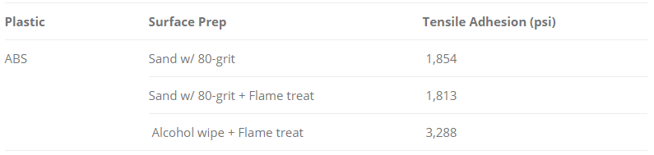

Application techniques (in depth):

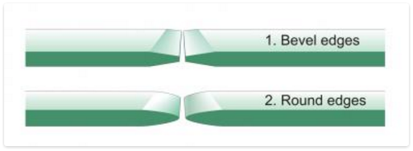

Fig 1. This diagram represents the two edge structures that will maximize strength of the bond.

Flame treatment:

* Use a propane torch and hold it such that the flame touches the surface
* Move the flame across the surface at a rate of 12-16 inches per second
* There should be no discolor or burns on the treated product
* The process will oxidize the surface which will improve adhesion
* Bond materials within 30 minutes of treatment

Mix ratio:

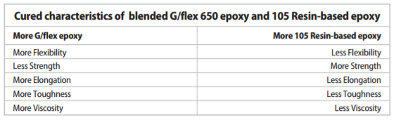

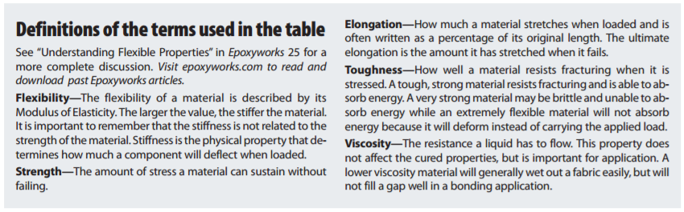

**Recommendations for XTC-3D:**

Application does not vary significantly with different parameters – although safety is the primary factor to stress, XTC-3D is very toxic and exothermic.